**Harmony Science**

**979-779-2100**

[hsabcs@harmonytx.org](mailto:hsabcs@harmonytx.org)

**Planning My Wedding**

### Name: Mackenzie Brooks

### **Driving Question**

* **How much money can I spend on my guests for dinner at my wedding?**
* **Parameters for my project:**
  + Plan wedding
  + $10,000 is the budget
  + Have to invite 250 people

#### The Math Behind the Magic!

* Wings
* Baked potatoes
* Fried green tomatoes
* Sweet tea

|  |  |
| --- | --- |
|  |  |
|  |  |
|  |  |

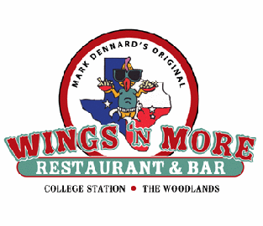

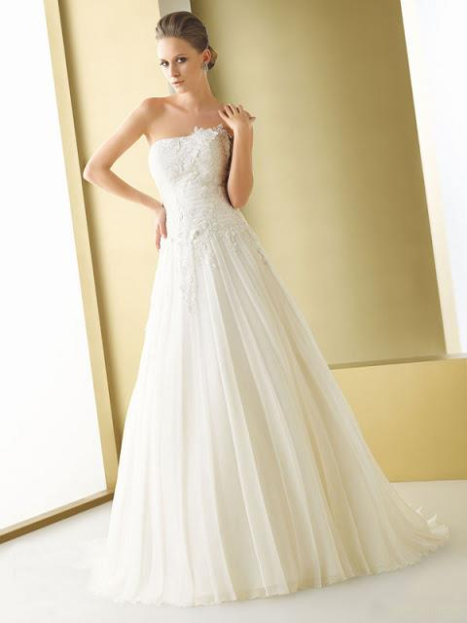

#### Menu

#### Ideas for My Dream Wedding

|  |
| --- |
| CAN SLOPE REALLY HELP ME PLAN MY WEDDING? |
| Y=M(X)+b  Y= my total cost of my wedding  M= the price per plate for dinner  X= the number of guests  B= the set expenses (flowers, dress, location) |
| THE MATH  $10,000 = m(250)+$4000 |

$10,000-$4000=M(250)

$6000=M(250)

M= 6000/250

M= $24 per plate

